***Career & Personal Counseling***

(For B.Ed Students ) Date- 6-7-2024

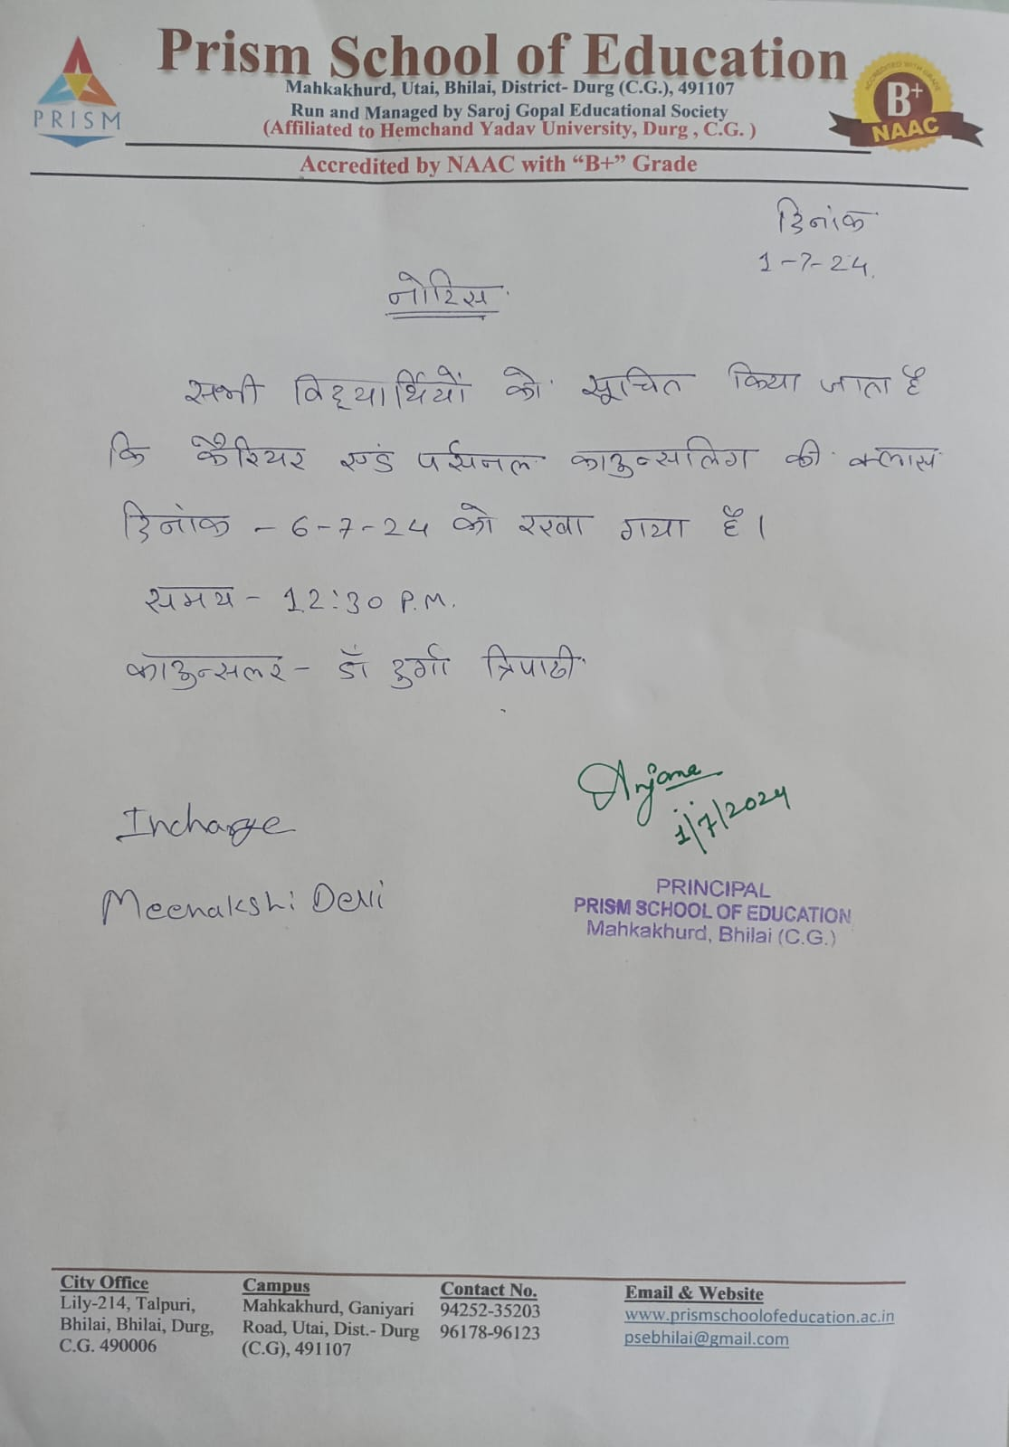



<https://youtu.be/sfGPUygPAN0>

