FDP DAY-6

Khalsa College is inviting you to a scheduled Zoom meeting.

Topic : valedictory session

Join Zoom Meeting

https://us04web.zoom.us/j/5104062738?pwd=V1RDS0xtNWtnbEIrV291YW5Db2FWZz09

Meeting ID: 510 406 2738

Passcode: v22mvK

Time: 12:00

Date : 15/06/2024

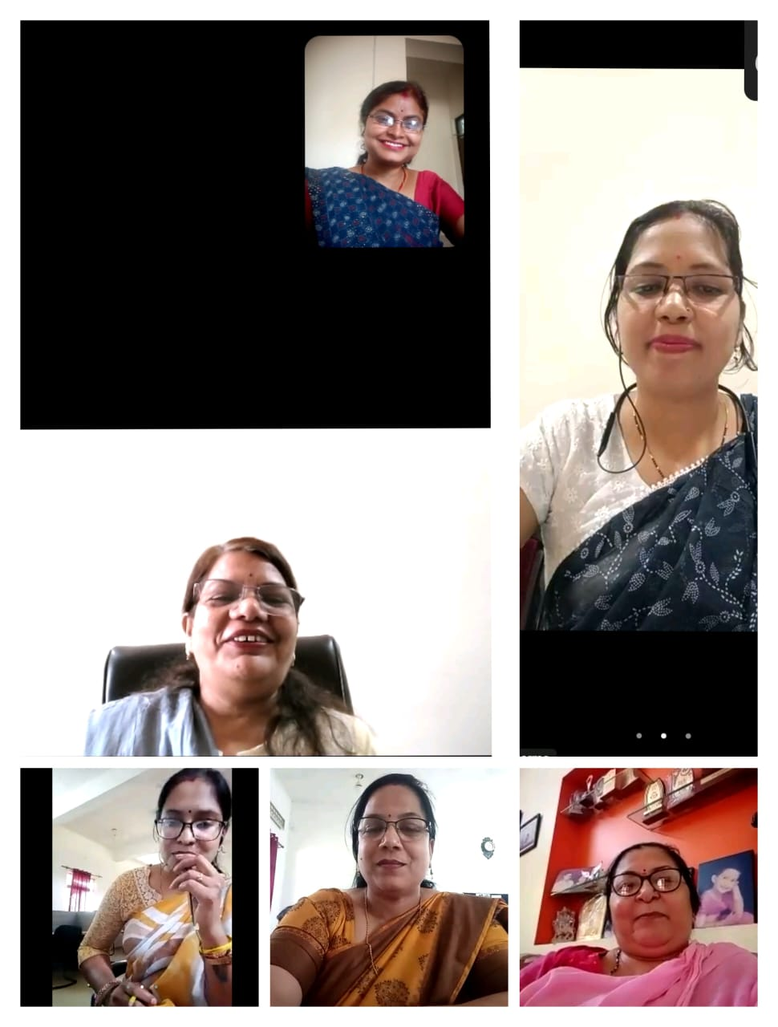

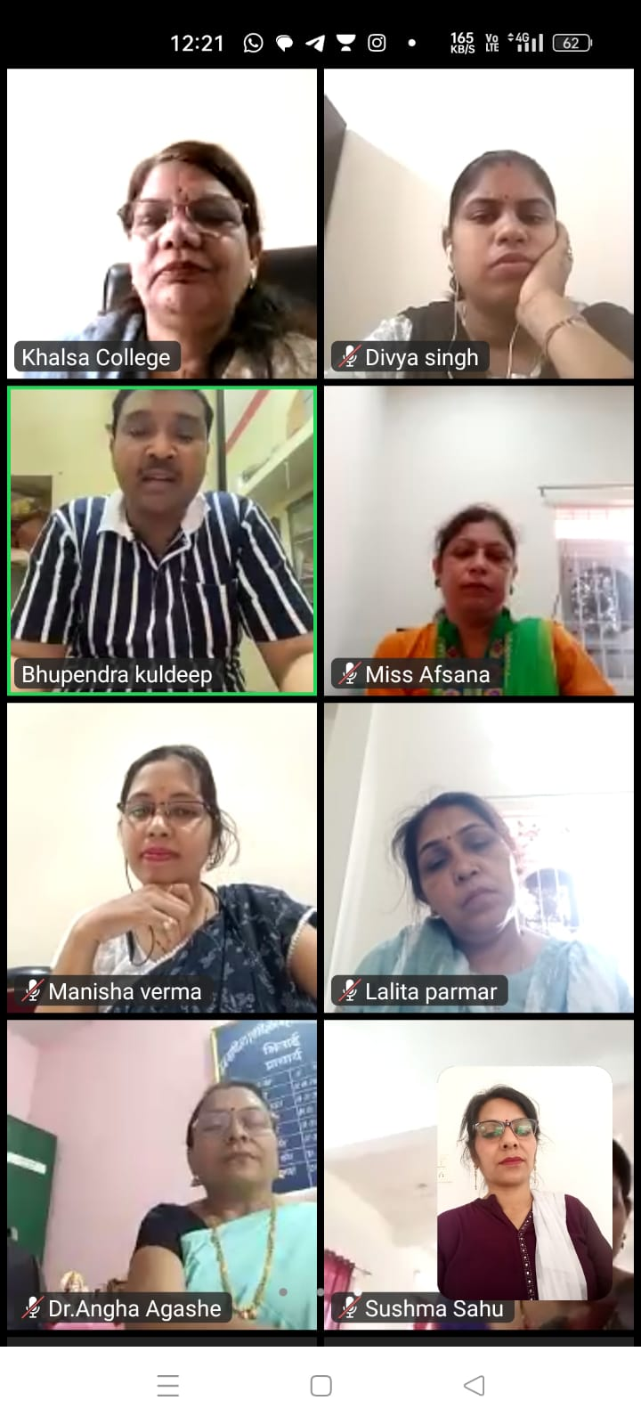

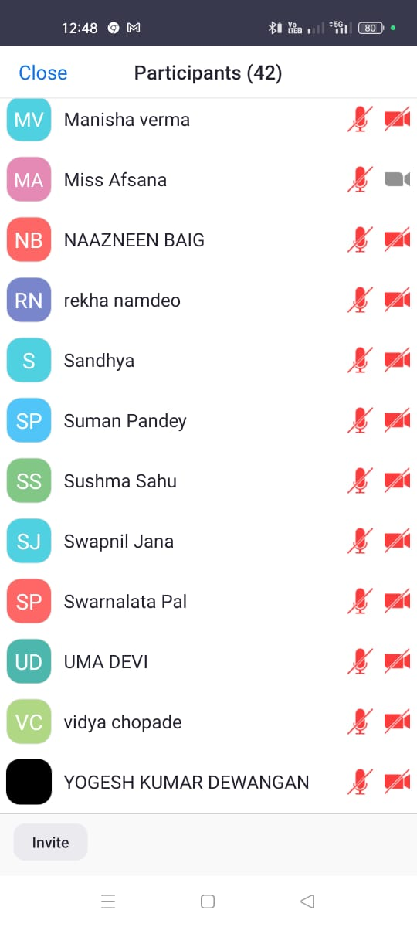

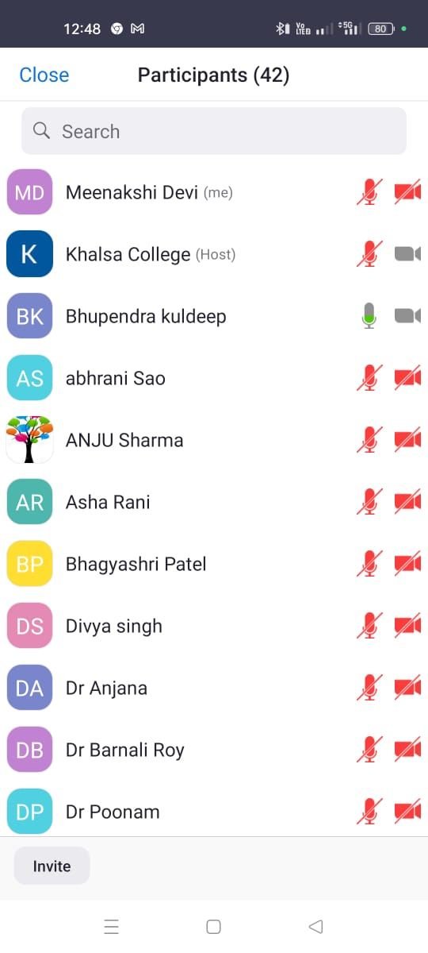

DAY-7 FDP -Sunday feedback

<https://docs.google.com/forms/d/e/1FAIpQLSfNyx1K5L4Sh85WXAR3_Z_izYY9NLxw0E7LkpIvb43Nz4u4lw/viewform?usp=sf_link>

