MICRO –TEACHING –TEACHER ORIENTATION DATE-15-6-2024

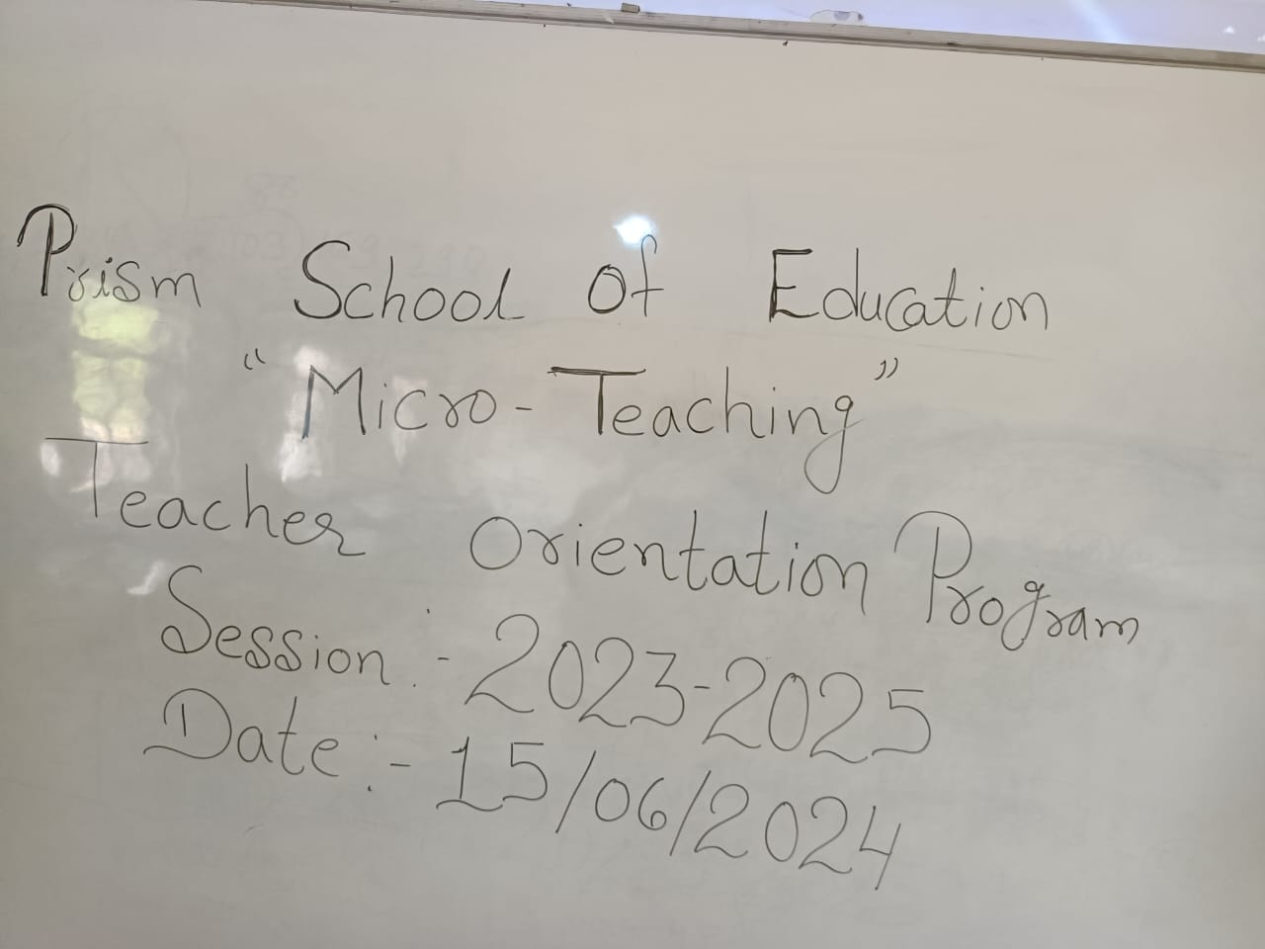

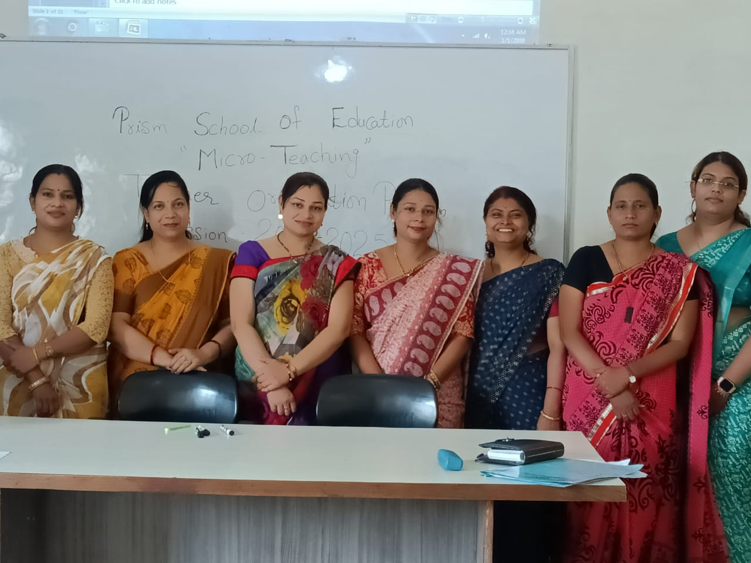

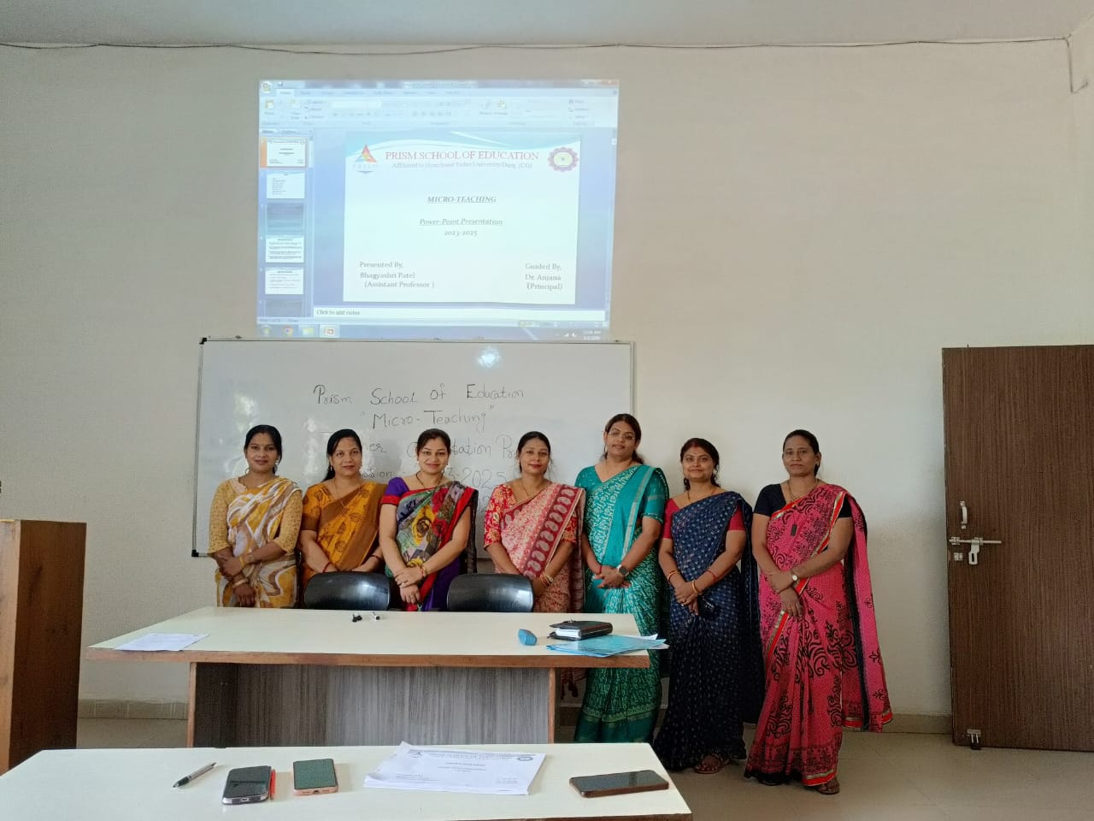

1-<https://youtu.be/vY88tq1G_W4>

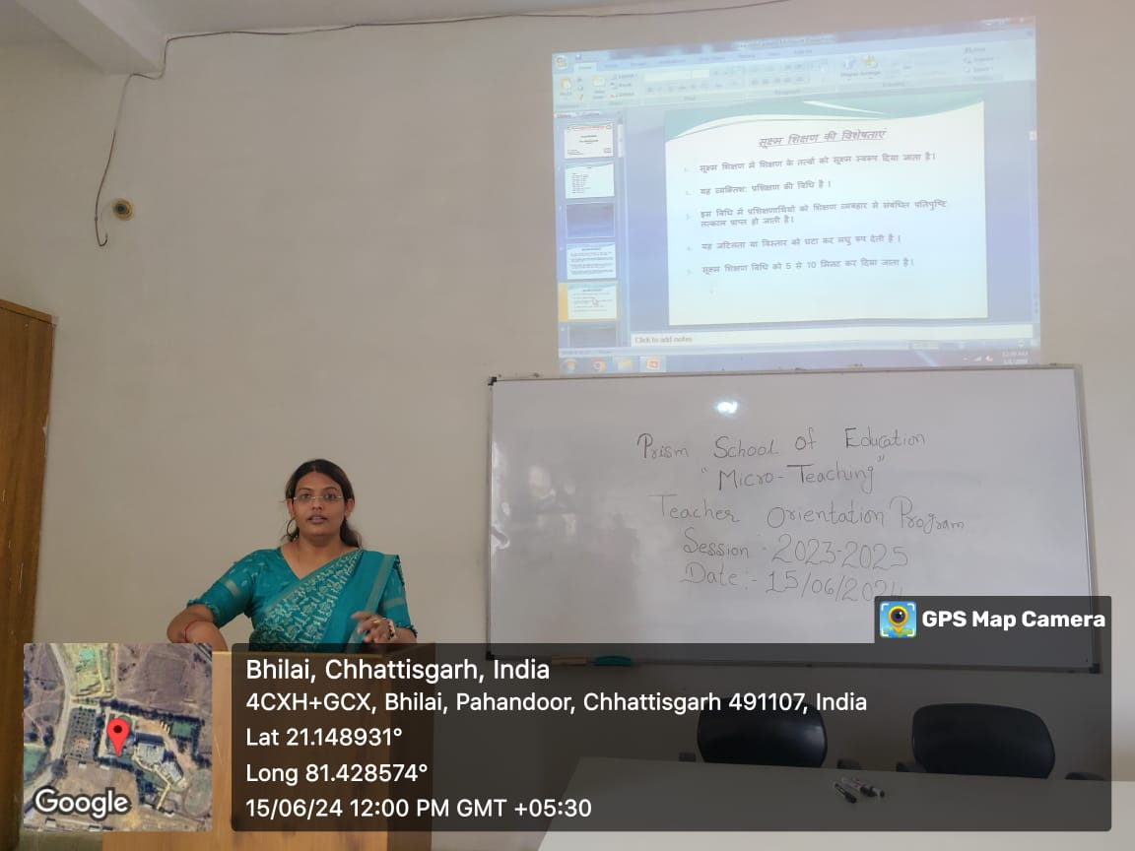

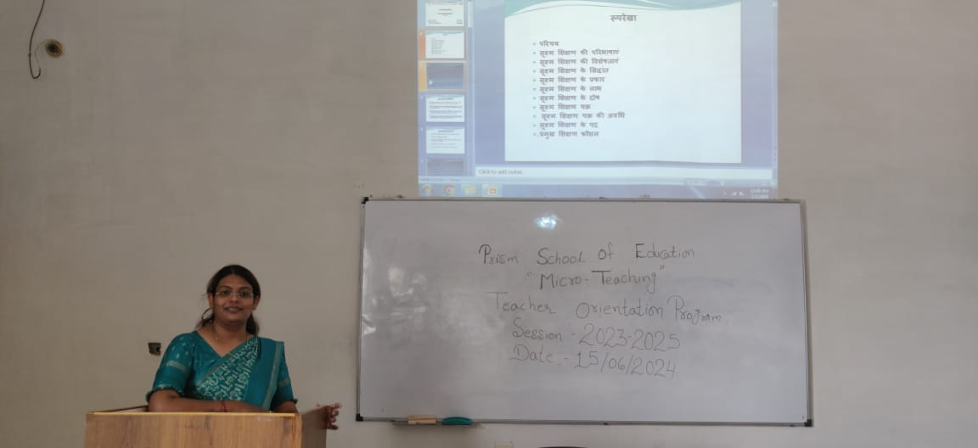

<https://youtu.be/fGDSn95AeZg>

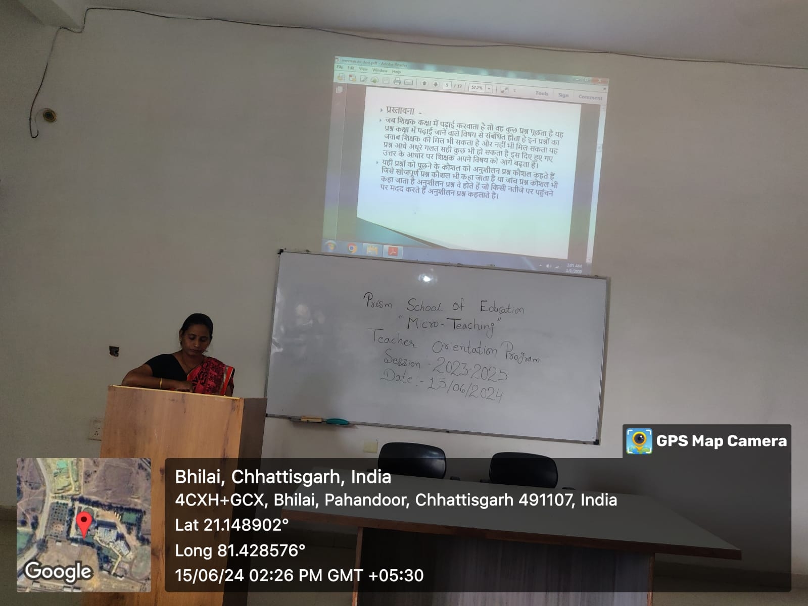

<https://youtu.be/DWPWtPm6APA>

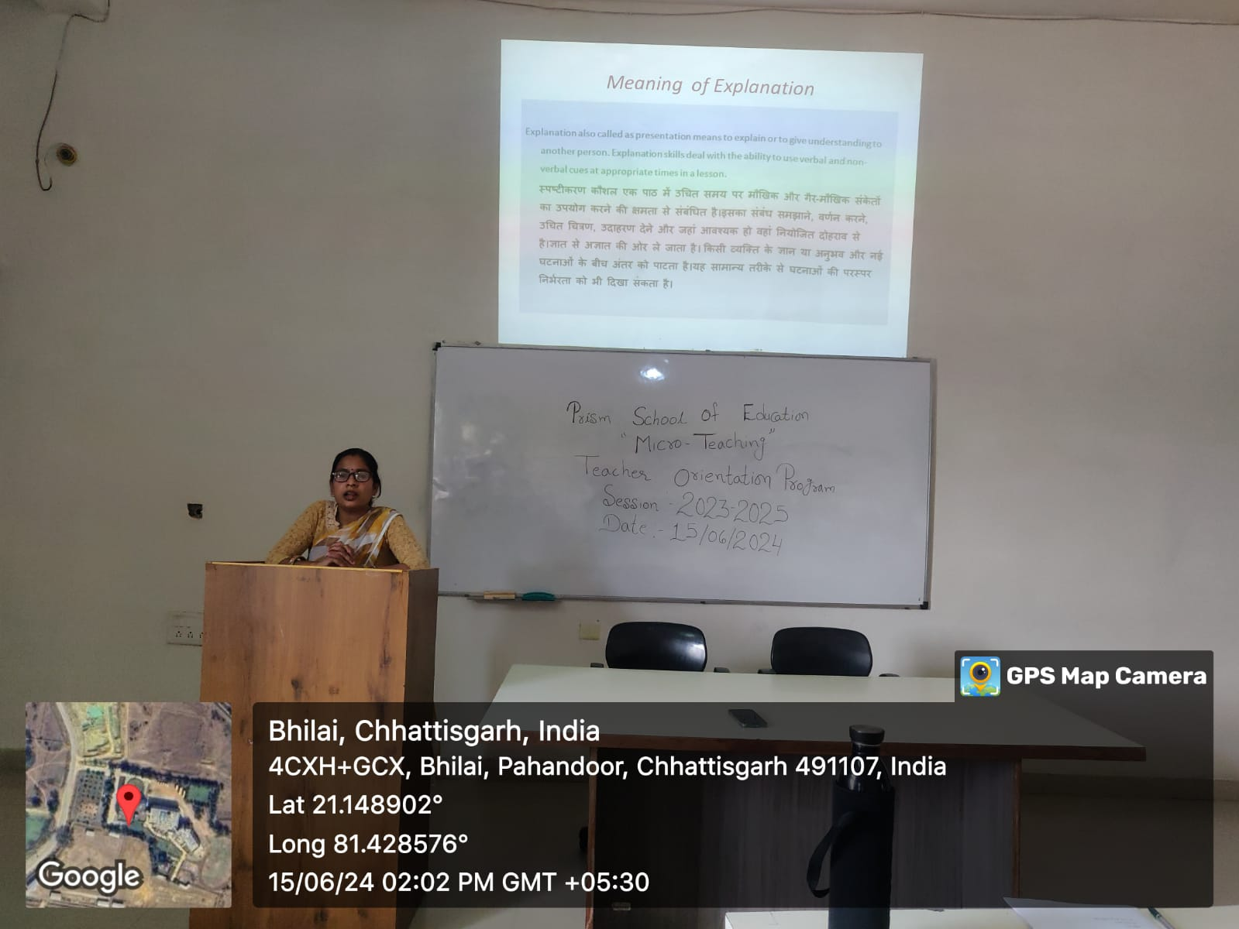

<https://youtu.be/ka978RMQBbU>

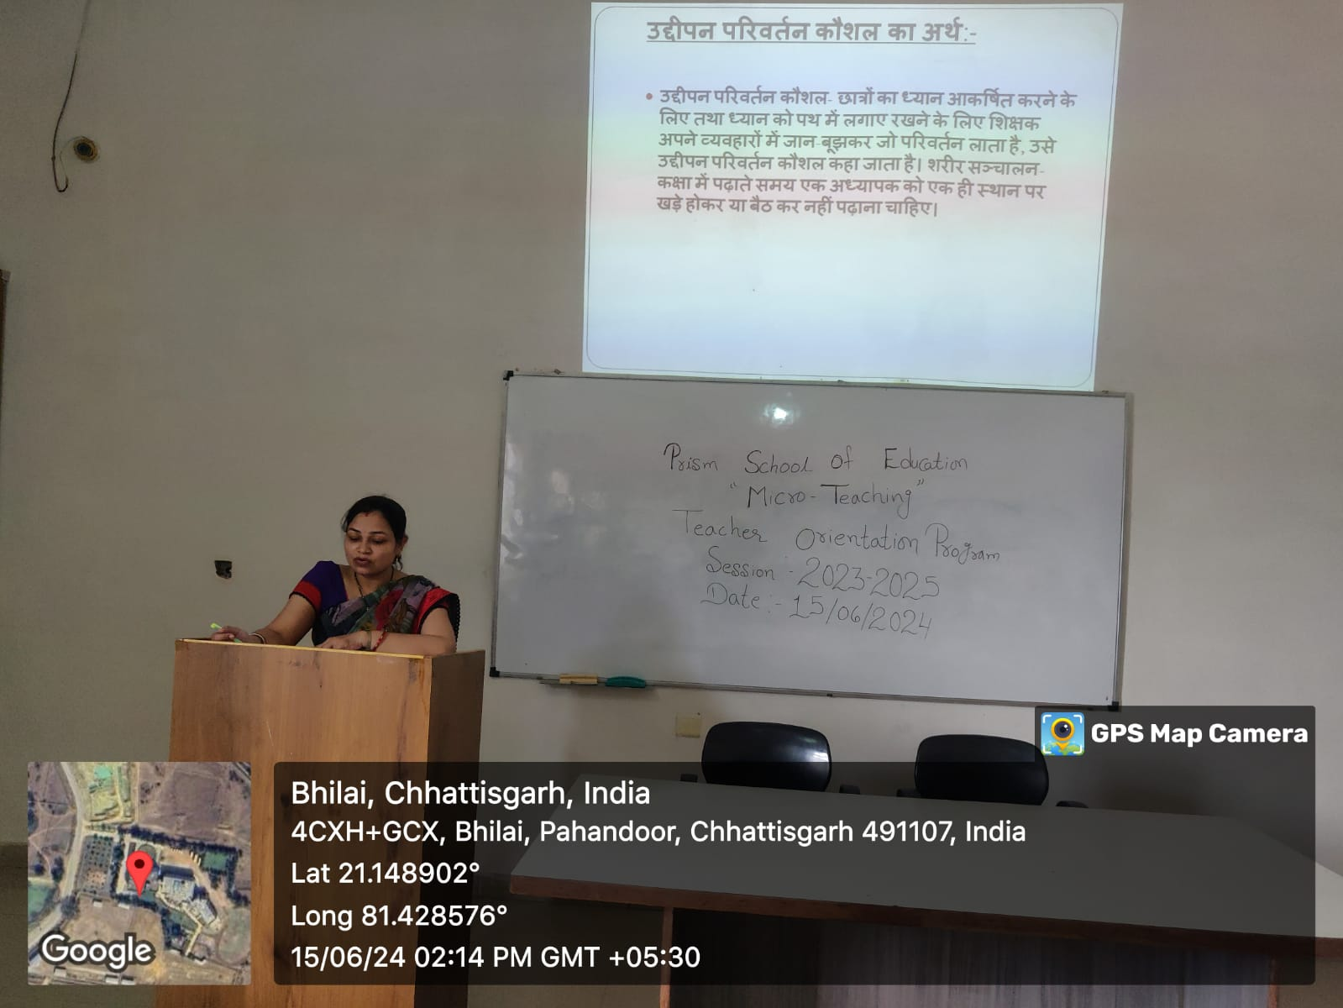

THANKYOU SPEECH-DR. DURGA MAM

