
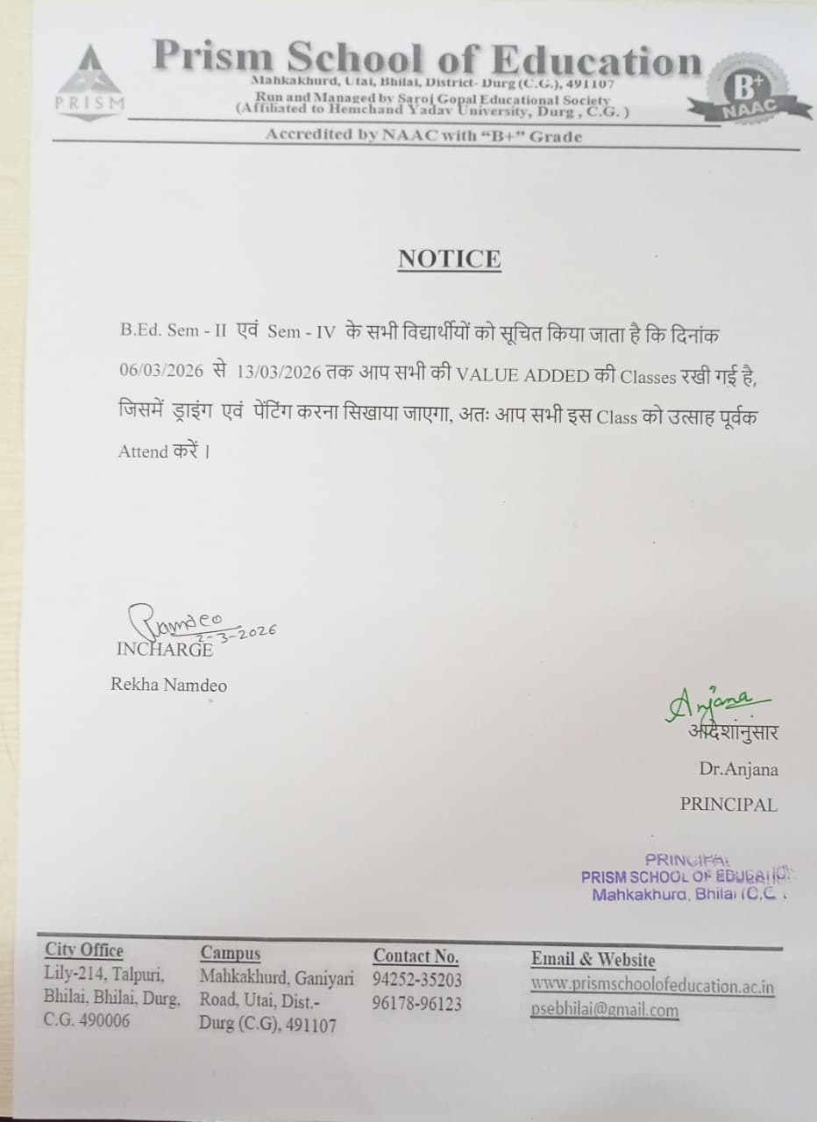
1 -https://youtube.com/live/QsInaZIdmmc

2- https://youtube.com/live/MZ2ZF6kiHEE

3- https://youtube.com/live/VotyKNkKL_k

4- https://youtube.com/live/rZgwhnf_95k

