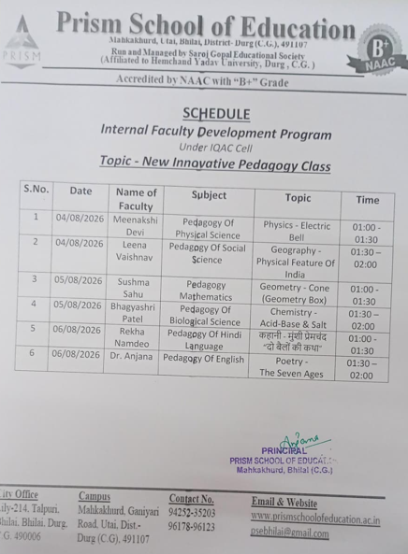
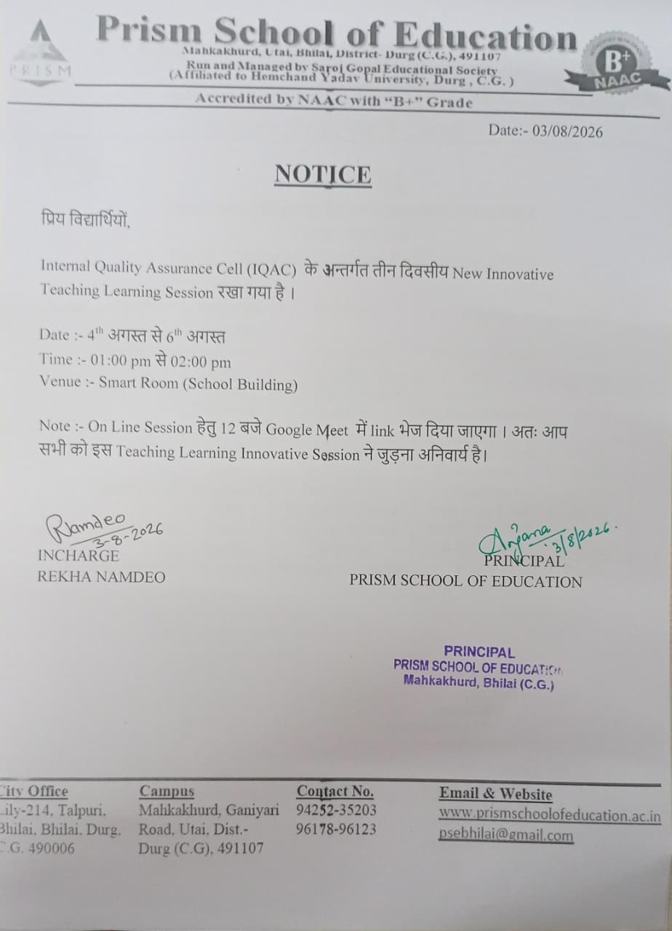

Meet, click this link:
https://meet.google.com/stp-kjnh-ybt
https://youtu.be/33zEteSIy6o

https://youtu.be/h2_oNZXvhTw

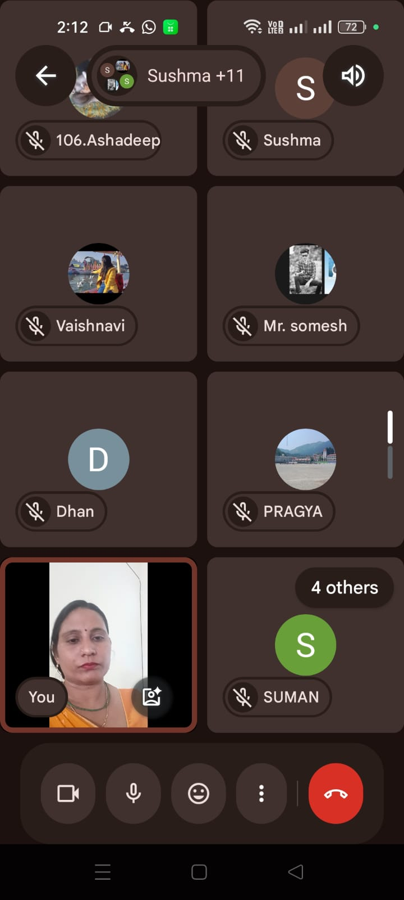

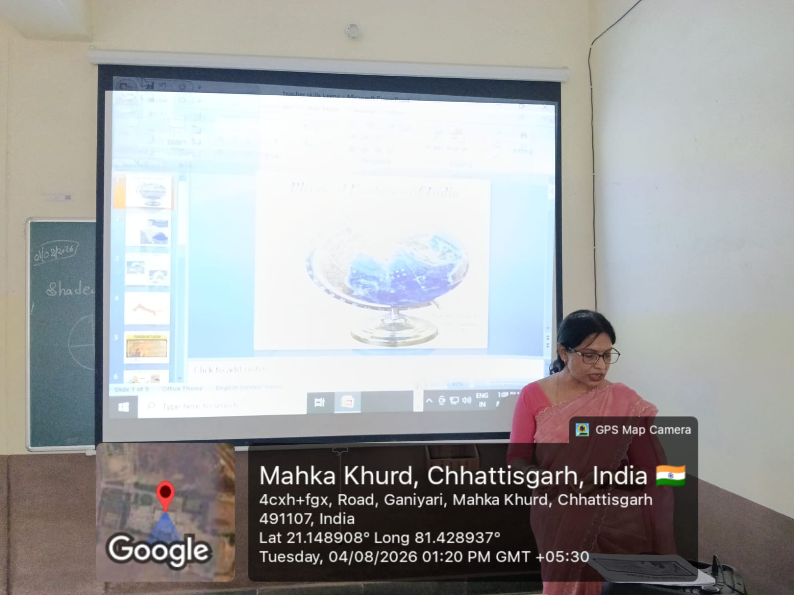
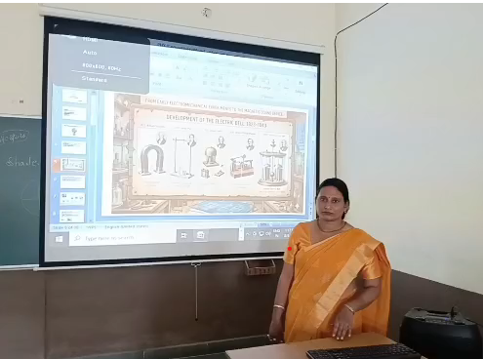
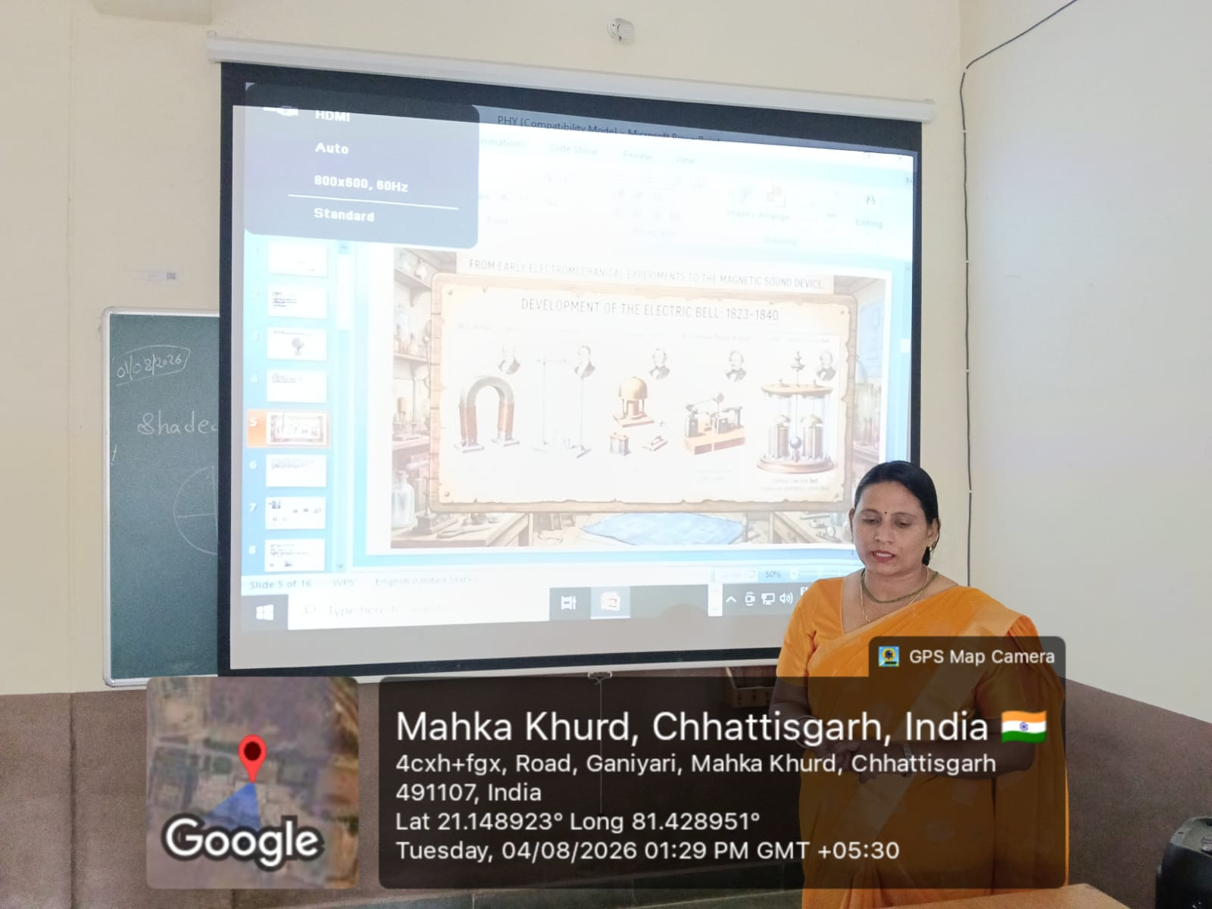
Day-2
https://meet.google.com/owq-nibe-ebm
class - https://www.youtube.com/live/-ufIz65NTiY?si=FqxbmgIyd_Ph00JS
class -https://www.youtube.com/live/2NubFVvPyLg?si=y4Lz5tC5OqDElbnS
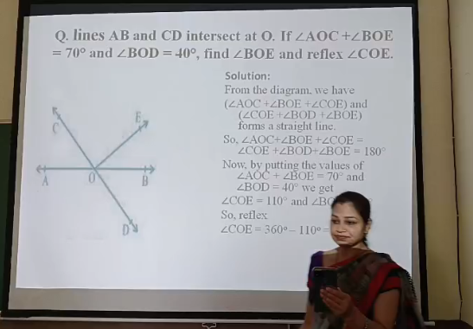
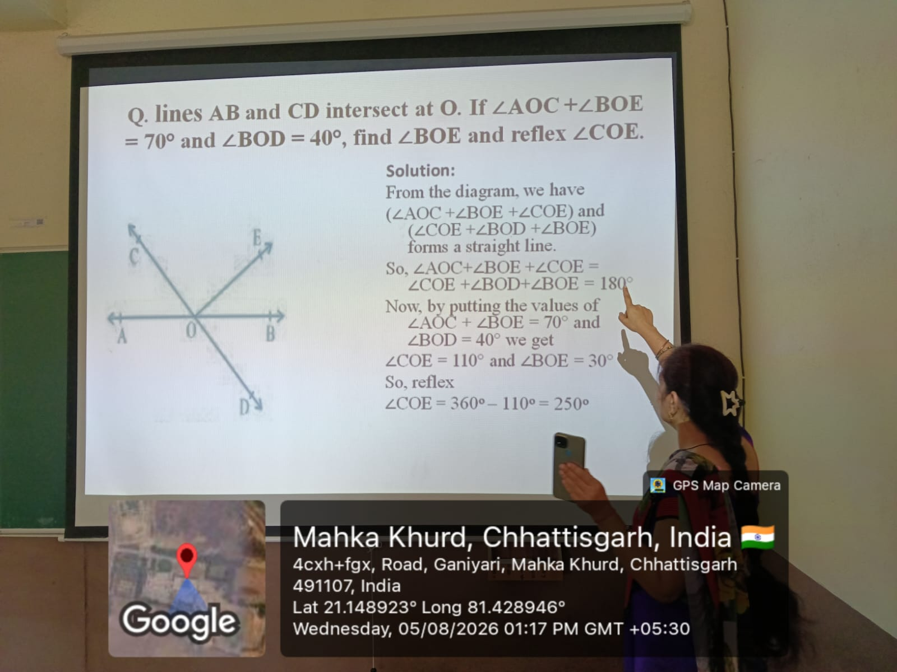

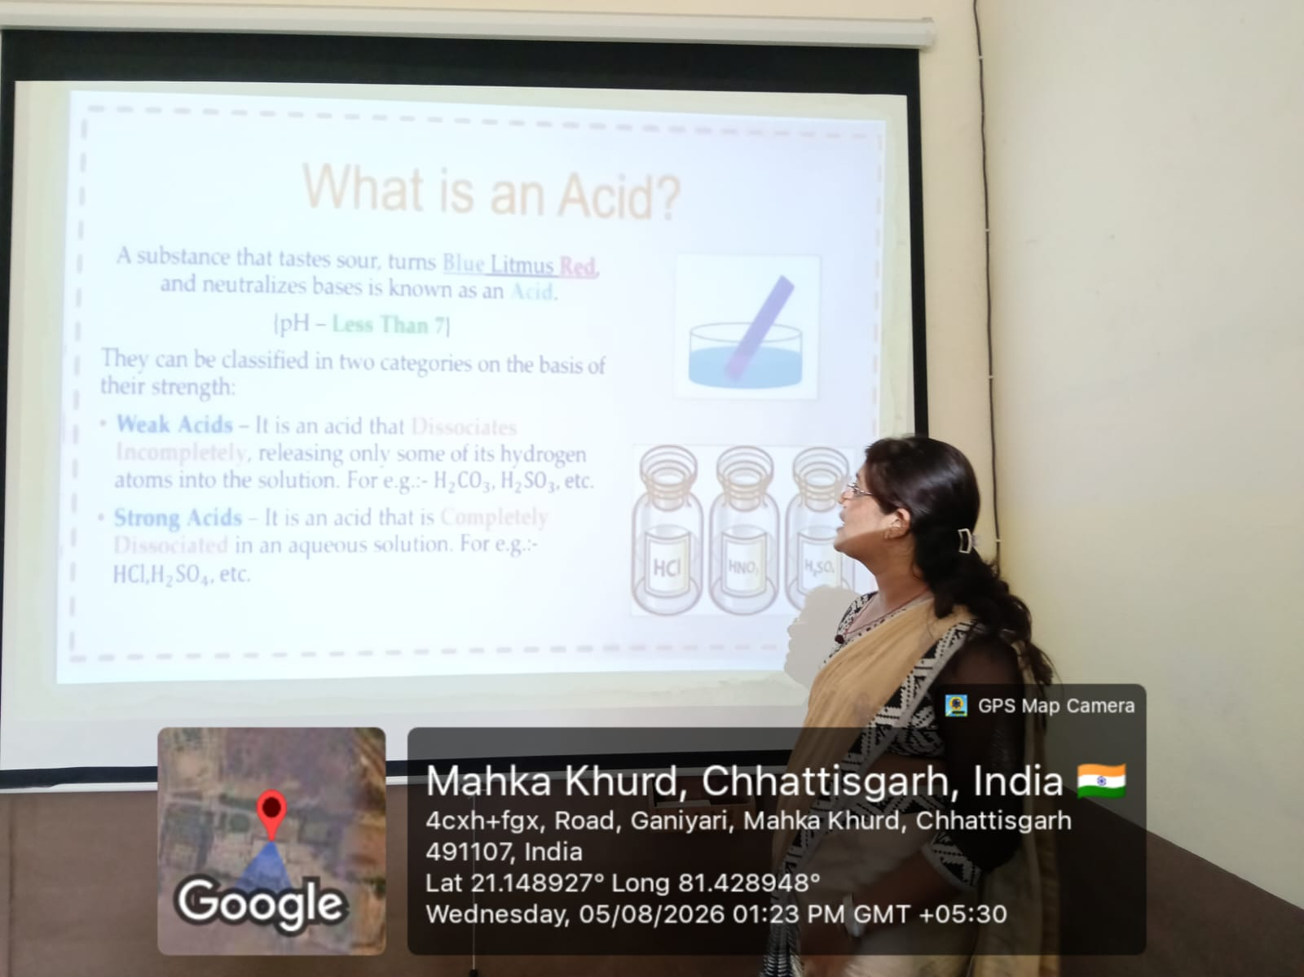
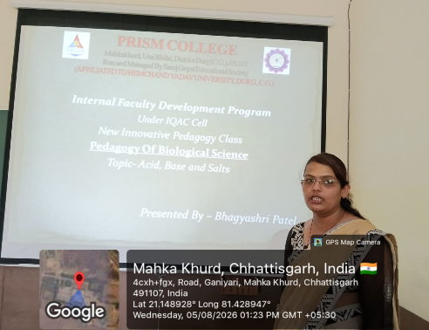

Day-3
https://meet.google.com/sdg-yzwk-wqq
https://www.youtube.com/live/na7z_DwVzxc?si=OC7tVFeT0g9eA8Me
https://www.youtube.com/live/FHAYG2LQKsk?si=TEnjiLHUqSQHFng0
