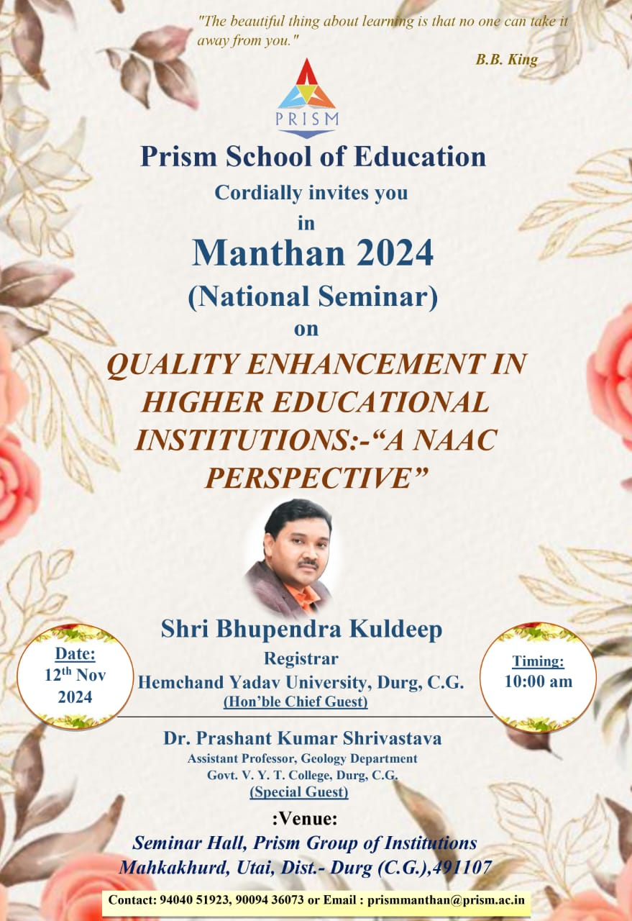

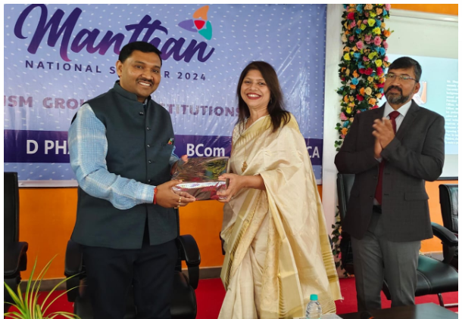

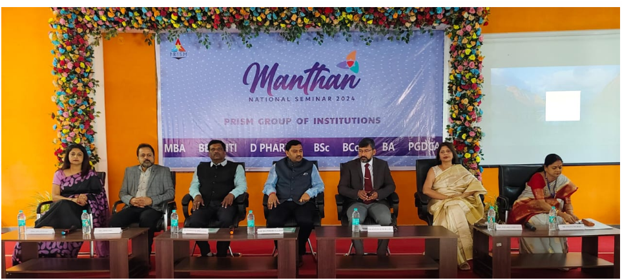

# 

# Session_1 & 2_Manthan 2024- National Seminar_ 12 NOV 2024 _ Prism School of Education

<https://www.youtube.com/live/JKJkpt7ZYW4?si=LMj07bS0Xn01B3Lz>

**Session_3 _4 & 5_Manthan 2024- National Seminar_ 12 NOV 2024 _ Prism School of Education**

<https://www.youtube.com/live/IbKhSXnBWxY?si=jZCv0DtL40Qo9yLF>

**Manthan DAY 2 SESSION 1(PCP)**

<https://www.youtube.com/live/n2Z5b-tgaqo?si=K2IVWJUyGs_e80Sl>

**MANTHAN DAY 2 SESSION 2 ITI**

<https://www.youtube.com/live/PdsW1p94KMQ?si=sdGP5FuUY5RVEufv>

**MANTHAN DAY 3 SESSION 1**

<https://www.youtube.com/live/Mv7gfYf32JE?si=XSIdw5Ehq54l8eEH>

**MANTHAN DAY 3 SESSION 2**

<https://www.youtube.com/live/szfI3I5COTw?si=ze7Sxhd5WdzWmawq>