<https://youtu.be/2kRZq0kkSBs>

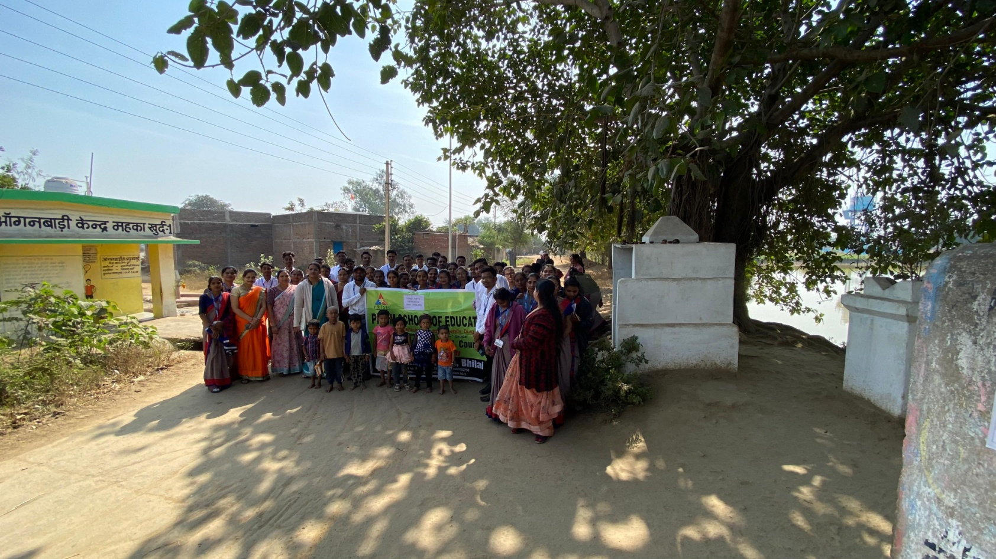

C:\Users\Admin\Desktop\rally 2025\WhatsApp Image 2025-01-15 at 10.36.49 AM.jpeg

