Workshop 2025(1-5-2025)

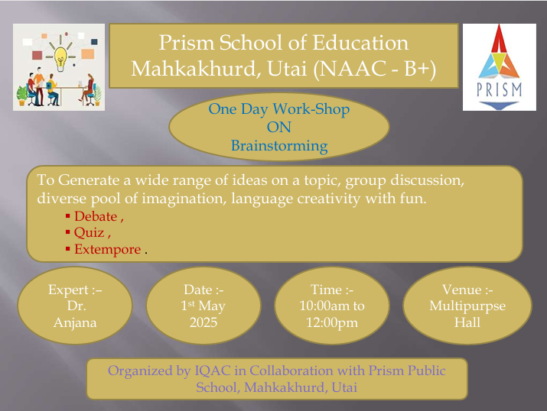

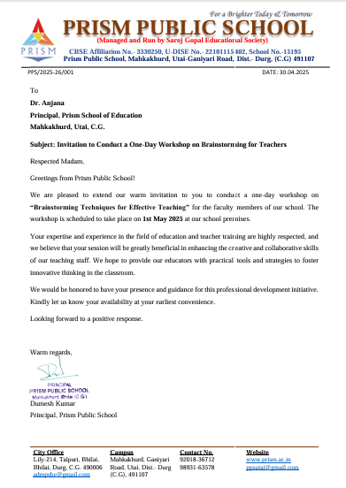

<https://www.prism.ac.in/prism-news-gallery/in-house-capacity-building-program-for-teachers>

<https://www.youtube.com/live/8n7-_Trv9mM?si=o-8aDPd9HWi0KoP4>

<https://www.youtube.com/live/6IRjD1tRleg?si=3jdGeXEkq_WpuSF2>

<https://www.youtube.com/live/xPUEKziKTaY?si=gCbs24Bj5CBfdm6P>

